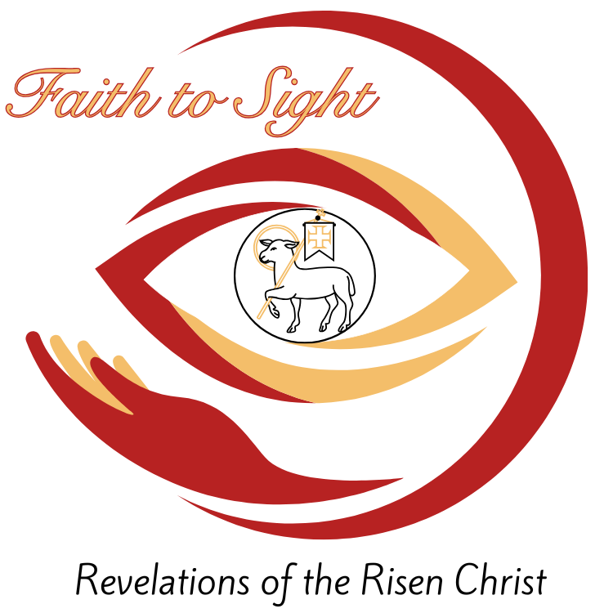
Sixth Sunday of Easter

CHRIST LUTHERAN CHURCH | Lodi, California
May 25, 2025
WELCOME TO WORSHIP
Welcome to Christ Lutheran Church. We pray that your soul will be strengthened by the good news about God’s grace, love, and forgiveness given to us. If you would like to learn more about our church, please speak with our pastor or one of our members after the service.
- Bathrooms are located in the fellowship hall. A changing table is located in the women’s bathroom.
WORSHIP THEME
Jesus will bring perfect joy to his people. Through the security that he grants by his death and resurrection, Christ promises eternal and unending blessings to those who trust in him.

Matins
Matins was the service that marked the beginning of a new day for the monastic orders. Morning is a natural and necessary time for prayer, praise, and worship. As we begin not just a new day, but a new week, we glorify God and ask for his blessing.
HYMN Dear Christians, One and All Rejoice|CW 557
M: In the name of the Father, and of the Son, and of the Holy Spirit.
C: Amen.
M: Christ is risen!
C: He is risen indeed.
M: If anyone is in Christ, he is a new creation; the old has gone, the new has come!
C: Thanks be to God! He gives us the victory through our Lord Jesus Christ.
M: If we live, we live to the Lord; and if we die, we die to the Lord.
C: So, whether we live or die, we belong to the Lord.
M: We were therefore buried with him through baptism into death in order that, just as Christ was raised from the dead through the glory of the Father,
C: We too may live a new life.
M: Death has been swallowed up in victory.
C: Where, O death, is your victory? Where, O death, is your sting?
CONFESSION
M: Upon the hill the cross now stands empty. Morning light has broken upon the tomb. As we come before our God and King, let us confess our sins.
C: Lord God, I humbly come before you.
I confess that I am sinful in thought, word, and deed.
I daily fail to do what you command, and continually do what you forbid.
Lord, I am sorry for my sins.
I believe that for the sake of my Lord Jesus Christ,
you will have mercy on me.
M: Upon this, your confession, by Christ’s command and authority, I forgive you all your sins. The vacant cross and empty grave are God’s signs to you that he has accepted the sacrifice of his one and only Son, and the power he wields in your baptism to make you new. Whoever believes this truth has eternal life.
The Lord is my strength and my song.
C: He has become my salvation.
PRAYER OF THE DAY
M: The Lord be with you.
C: And also with you.
M: Let us pray.
Father of lights, every good and perfect gift comes from you. Inspire us to think those things that are true and long for those things that are good, that we may always make our petitions according to your gracious will; through your Son, Jesus Christ our Lord, who lives and reigns with you and the Holy Spirit, one God, now and forever.
C: Amen

M: Christ is risen, he is risen indeed! Let us worship him.
O COME LET US SING TO THE LORD
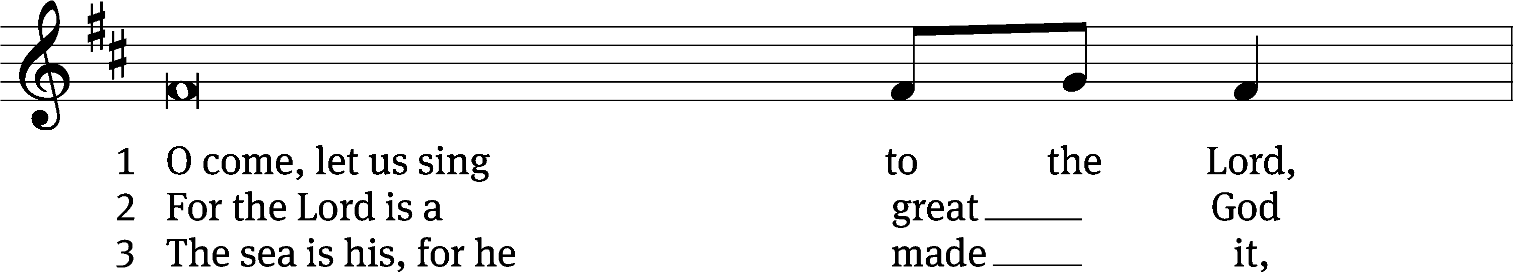
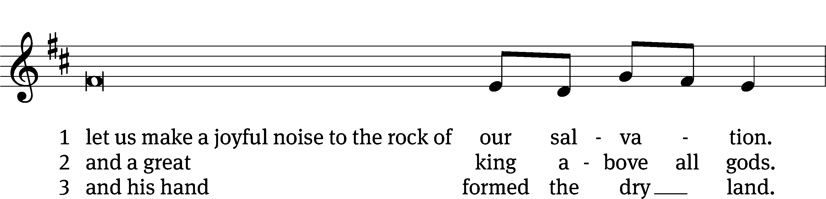
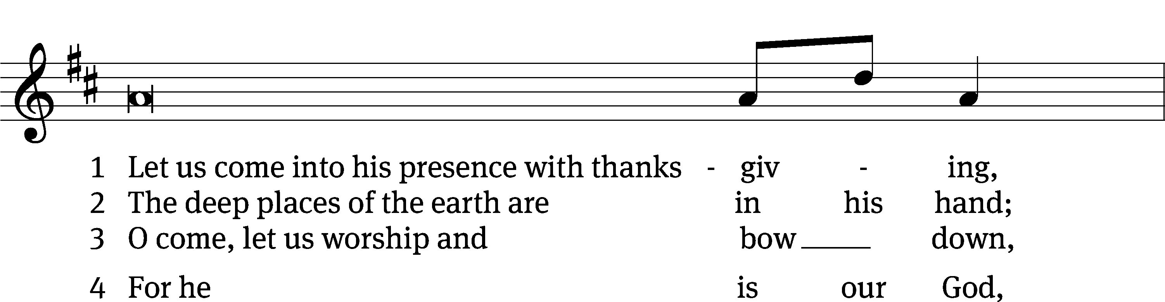
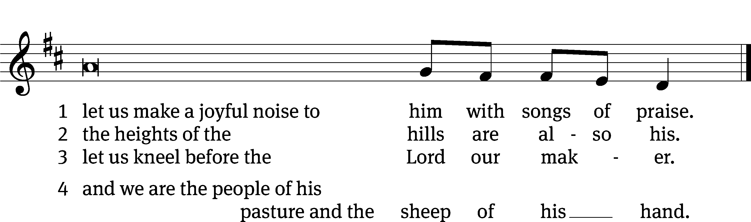

FIRST LESSON Acts 14:8-22
Paul and Barnabas preach the good news in Lystra.
⁸ In Lystra there sat a man who was lame. He had been that way from birth and had never walked. ⁹ He listened to Paul as he was speaking. Paul looked directly at him, saw that he had faith to be healed ¹⁰ and called out, “Stand up on your feet!” At that, the man jumped up and began to walk.
¹¹ When the crowd saw what Paul had done, they shouted in the Lycaonian language, “The gods have come down to us in human form!” ¹² Barnabas they called Zeus, and Paul they called Hermes because he was the chief speaker. ¹³ The priest of Zeus, whose temple was just outside the city, brought bulls and wreaths to the city gates because he and the crowd wanted to offer sacrifices to them.
¹⁴ But when the apostles Barnabas and Paul heard of this, they tore their clothes and rushed out into the crowd, shouting: ¹⁵ “Friends, why are you doing this? We too are only human, like you. We are bringing you good news, telling you to turn from these worthless things to the living God, who made the heavens and the earth and the sea and everything in them. ¹⁶ In the past, he let all nations go their own way. ¹⁷ Yet he has not left himself without testimony: He has shown kindness by giving you rain from heaven and crops in their seasons; he provides you with plenty of food and fills your hearts with joy.” ¹⁸ Even with these words, they had difficulty keeping the crowd from sacrificing to them.
¹⁹ Then some Jews came from Antioch and Iconium and won the crowd over. They stoned Paul and dragged him outside the city, thinking he was dead. ²⁰ But after the disciples had gathered around him, he got up and went back into the city. The next day he and Barnabas left for Derbe.
²¹ They preached the gospel in that city and won a large number of disciples. Then they returned to Lystra, Iconium and Antioch, ²² strengthening the disciples and encouraging them to remain true to the faith. “We must go through many hardships to enter the kingdom of God,” they said.

PSALM Psalm 65
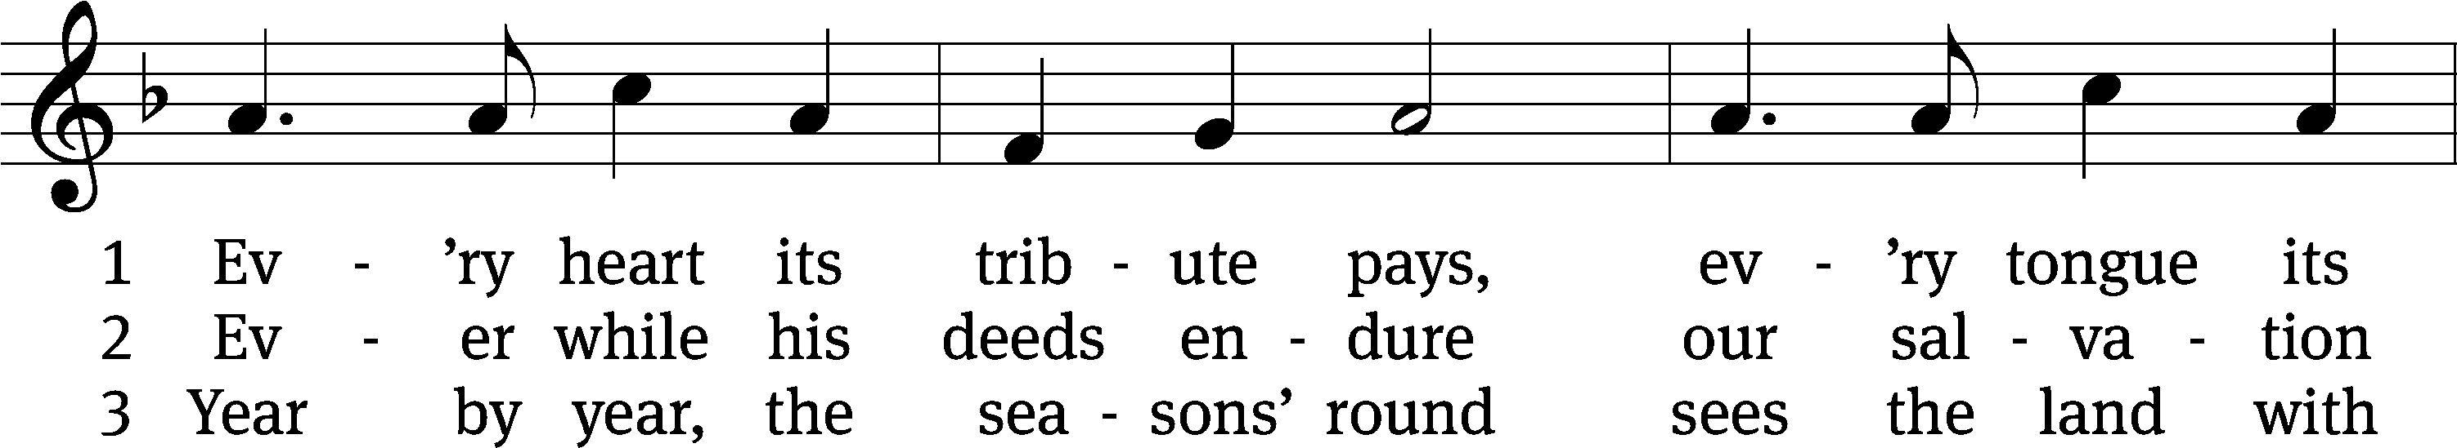
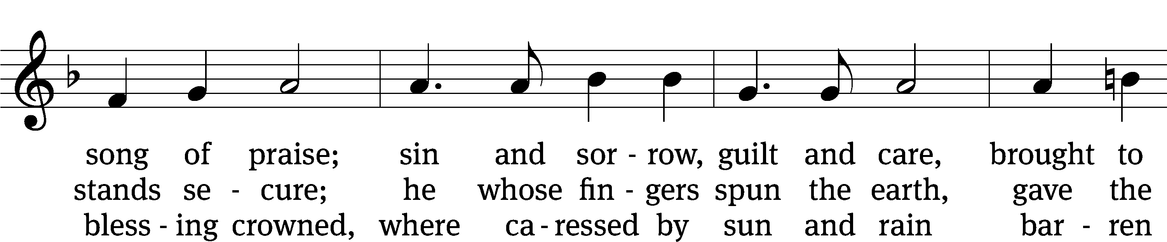
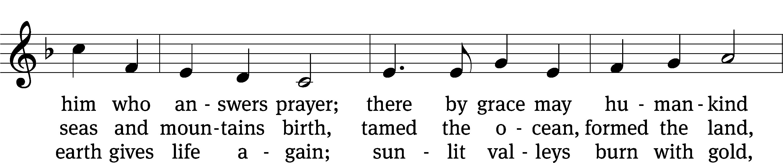
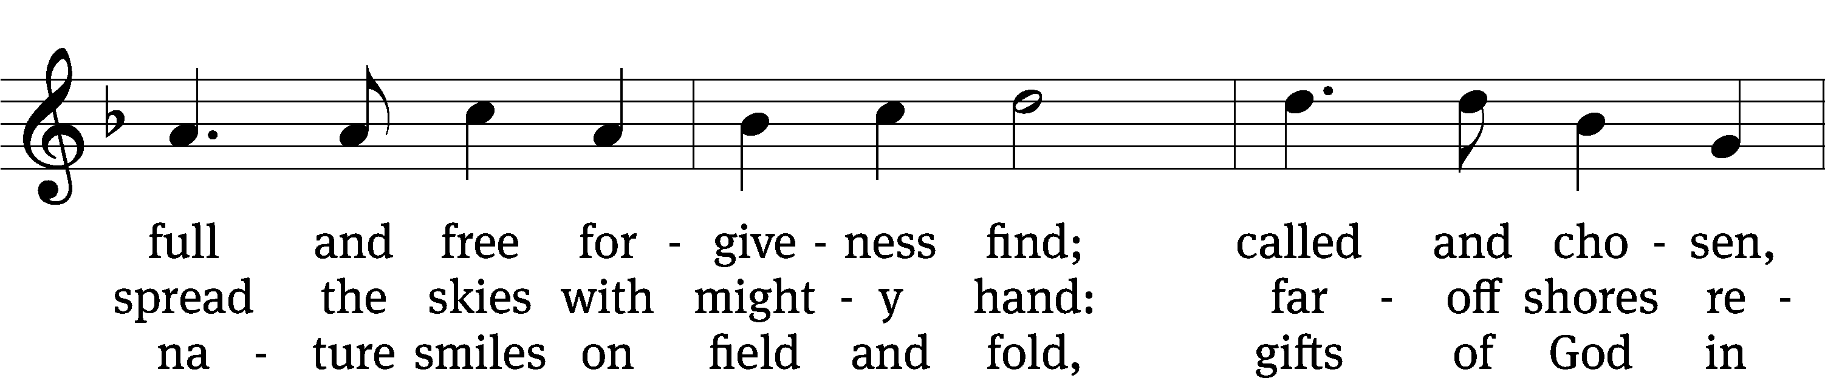
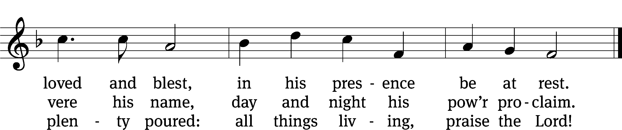

Text: Timothy Dudley-Smith
Tune: George J. Elvey
Text: © 1984 Hope Publishing Co. Used by permission: OneLicense no. 718312
Tune: Public domain

SECOND LESSON Revelation 21:10-14;22–27
The New Jerusalem is secure.
¹⁰ And he carried me away in the Spirit to a mountain great and high, and showed me the Holy City, Jerusalem, coming down out of heaven from God. ¹¹ It shone with the glory of God, and its brilliance was like that of a very precious jewel, like a jasper, clear as crystal. ¹² It had a great, high wall with twelve gates, and with twelve angels at the gates. On the gates were written the names of the twelve tribes of Israel. ¹³ There were three gates on the east, three on the north, three on the south and three on the west. ¹⁴ The wall of the city had twelve foundations, and on them were the names of the twelve apostles of the Lamb.
²² I did not see a temple in the city, because the Lord God Almighty and the Lamb are its temple. ²³ The city does not need the sun or the moon to shine on it, for the glory of God gives it light, and the Lamb is its lamp. ²⁴ The nations will walk by its light, and the kings of the earth will bring their splendor into it. ²⁵ On no day will its gates ever be shut, for there will be no night there. ²⁶ The glory and honor of the nations will be brought into it. ²⁷ Nothing impure will ever enter it, nor will anyone who does what is shameful or deceitful, but only those whose names are written in the Lamb’s book of life.
VERSE OF THE DAY John 14:23
Alleluia. Alleluia. Christ is risen! He is risen indeed! Alleluia. If anyone loves me, he will obey my teaching. My Father will love him, and we will come to him and make our home with him. Alleluia.
THE GOSPEL John 16:16-24
Jesus promises to complete his disciples’ joy.
¹⁶ Jesus went on to say, “In a little while you will see me no more, and then after a little while you will see me.”
¹⁷ At this, some of his disciples said to one another, “What does he mean by saying, ‘In a little while you will see me no more, and then after a little while you will see me,’ and ‘Because I am going to the Father’?” ¹⁸ They kept asking, “What does he mean by ‘a little while’? We don’t understand what he is saying.”
¹⁹ Jesus saw that they wanted to ask him about this, so he said to them, “Are you asking one another what I meant when I said, ‘In a little while you will see me no more, and then after a little while you will see me’? ²⁰ Very truly I tell you, you will weep and mourn while the world rejoices. You will grieve, but your grief will turn to joy.
²¹ A woman giving birth to a child has pain because her time has come; but when her baby is born she forgets the anguish because of her joy that a child is born into the world. ²² So with you: Now is your time of grief, but I will see you again and you will rejoice, and no one will take away your joy. ²³ In that day you will no longer ask me anything. Very truly I tell you, my Father will give you whatever you ask in my name. ²⁴ Until now you have not asked for anything in my name. Ask and you will receive, and your joy will be complete.
M The Gospel of the Lord.
C: Praise be to you, O Christ!
HYMN OF THE DAY Jerusalem the Golden| CW 889
SERMON Revelation 21
WE PRAISE YOU, O GOD
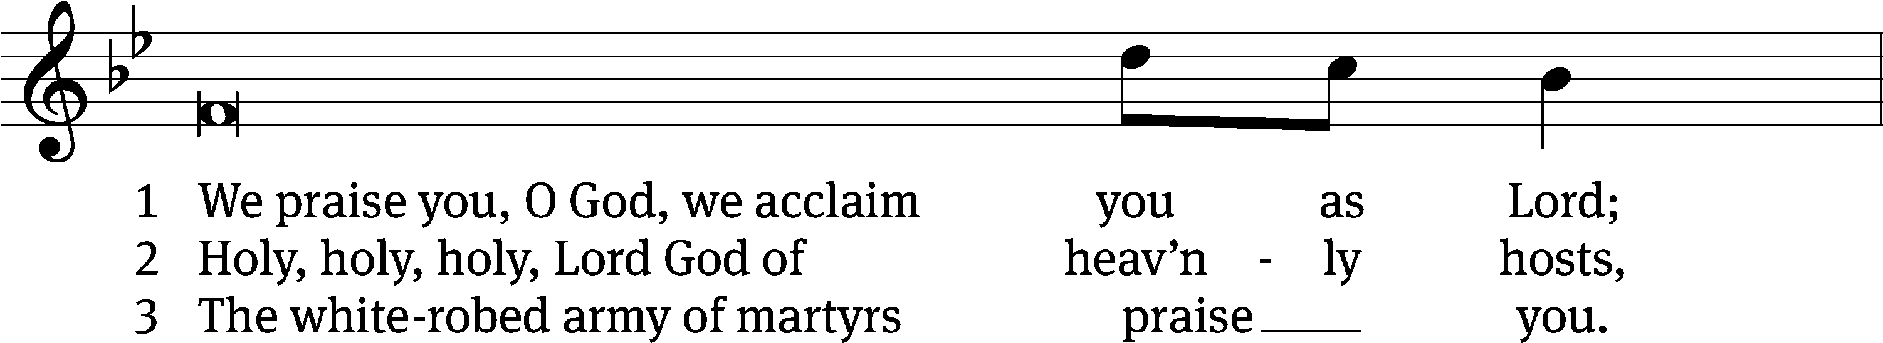
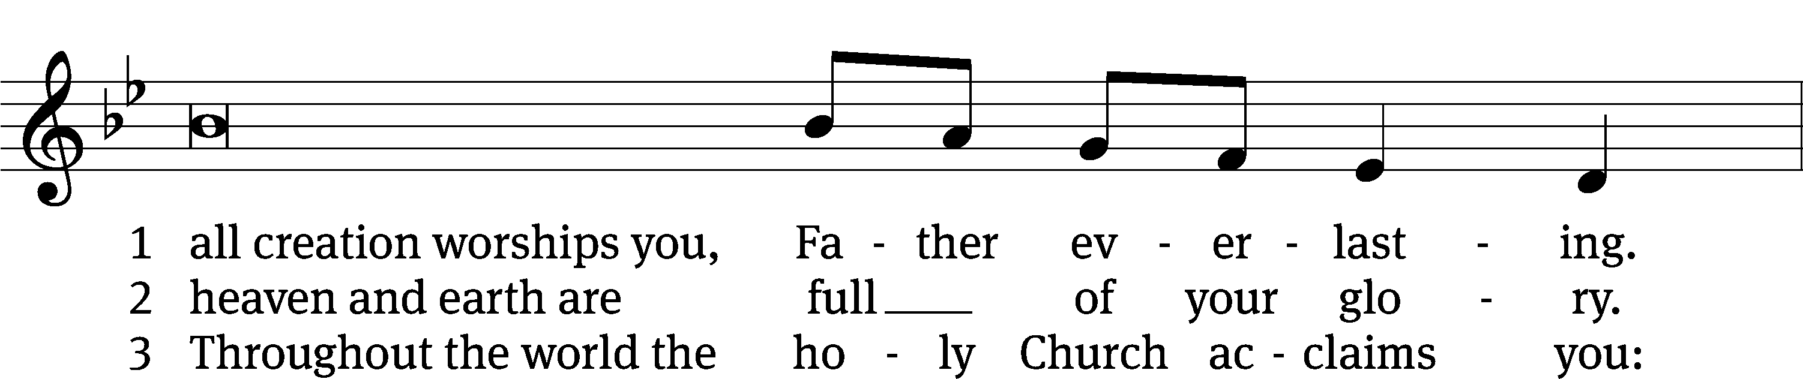
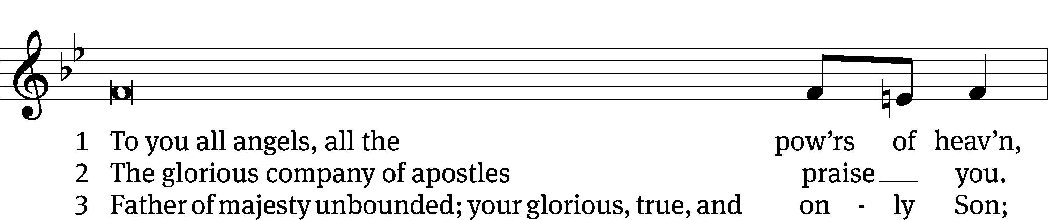
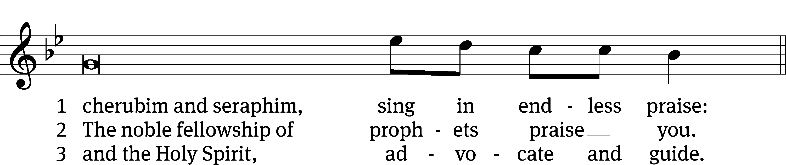

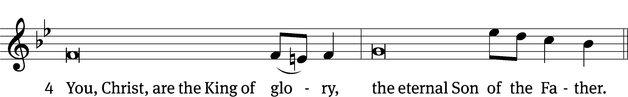
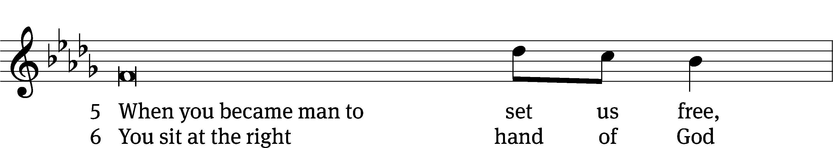
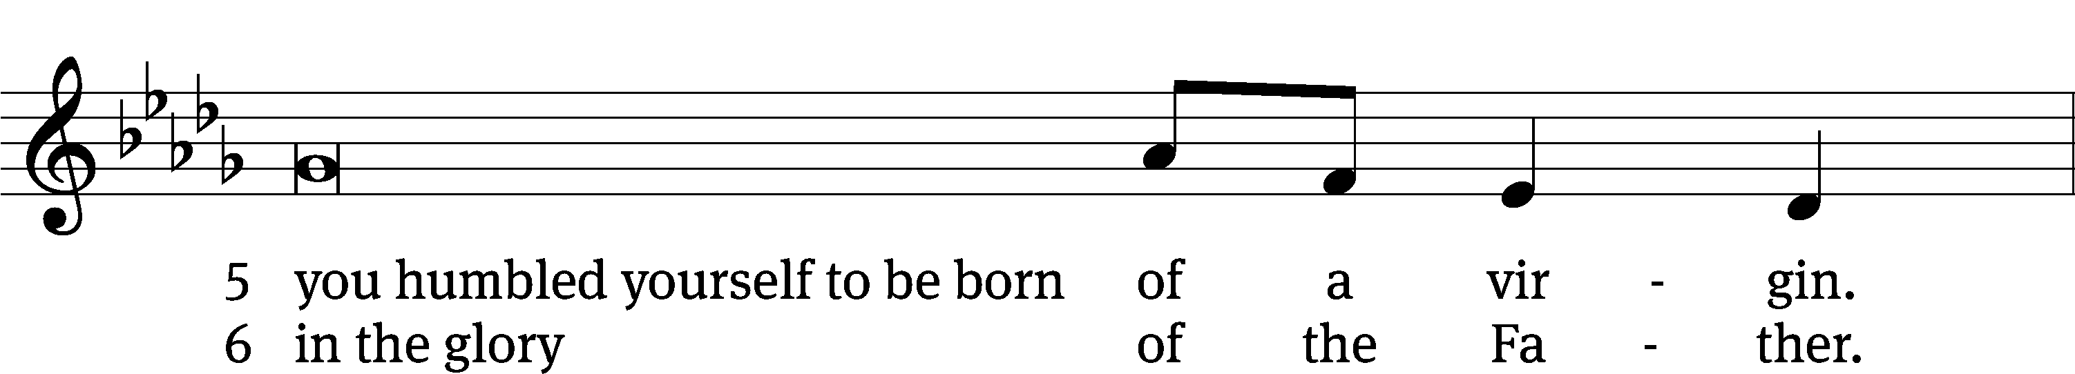
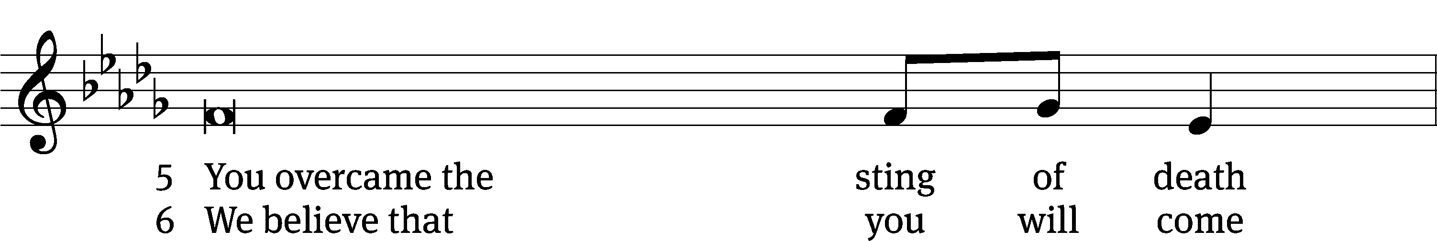
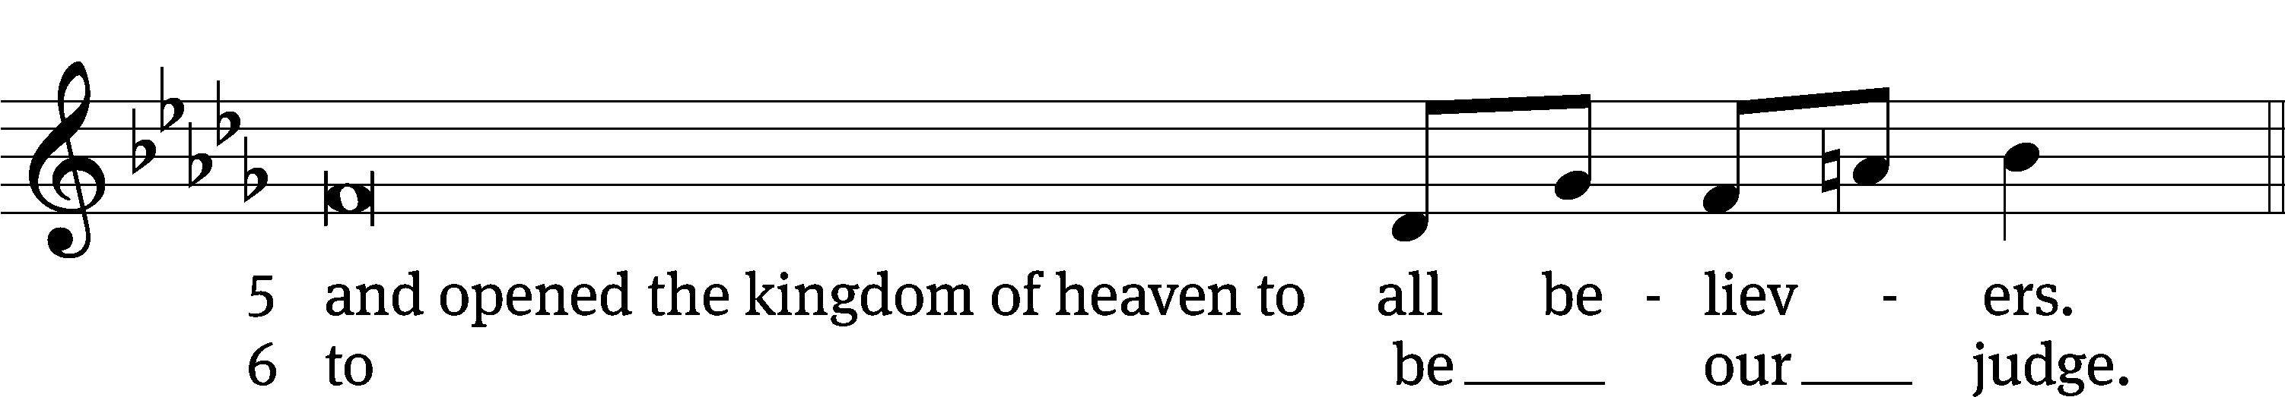
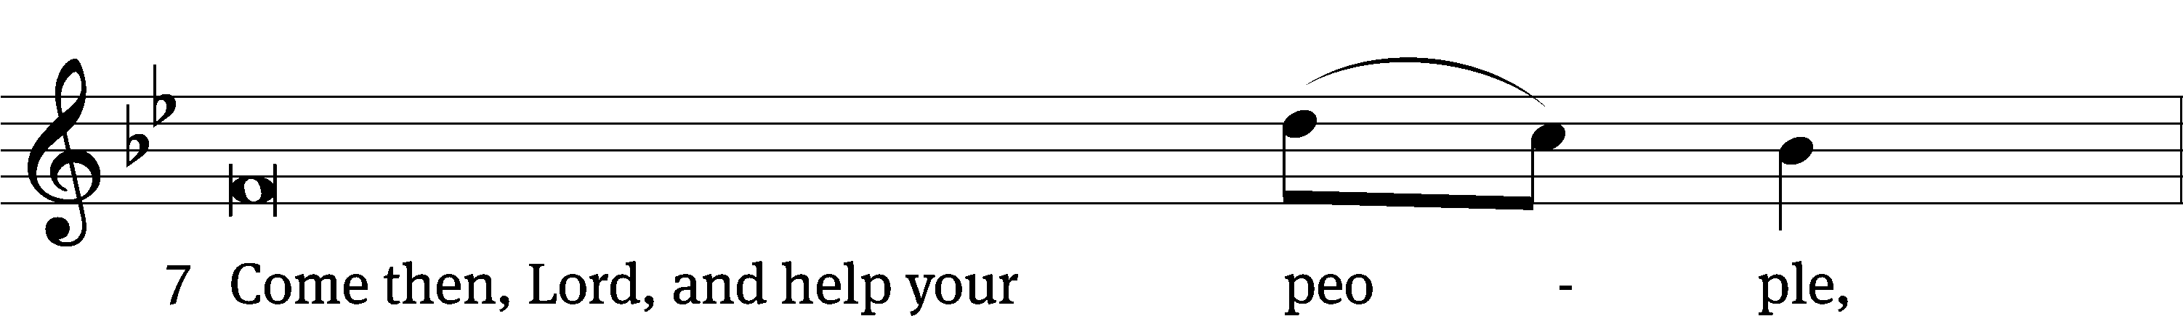
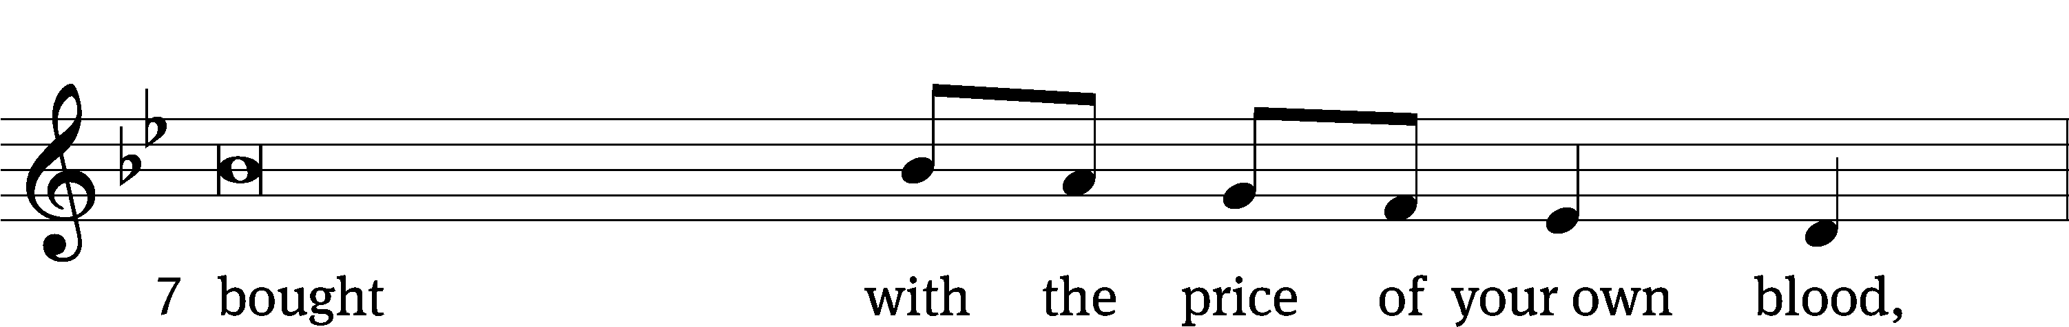
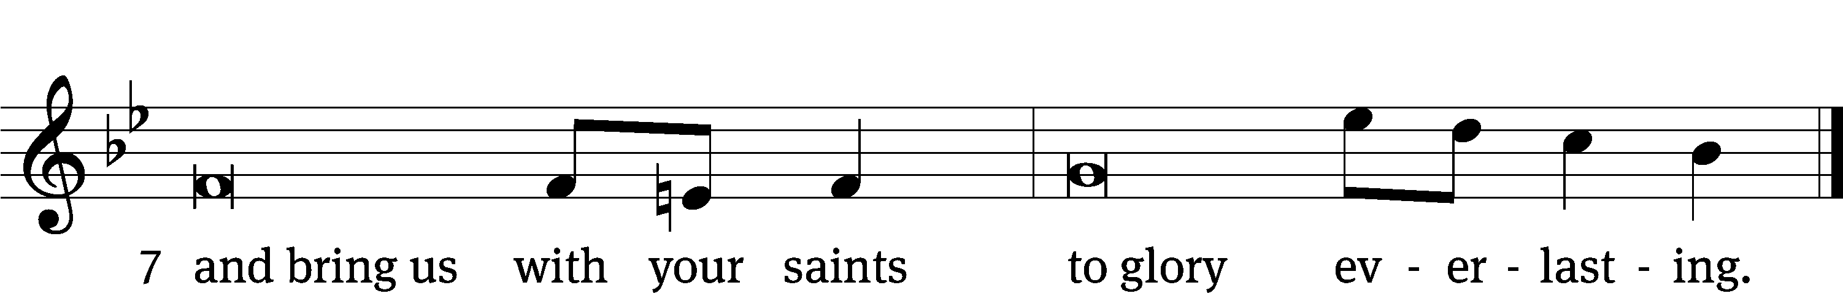

OFFERING
In response to God’s love and forgiveness, we give back a portion of what he has given us. The members of Christ Lutheran Church have joined to proclaim the gospel to this community. These offerings support that work. While our guests are welcome to participate, they should not feel obligated to do so.
PRAYER OF THE CHURCH
M: Lord God, our heavenly Father, You never refuse the cries of Your children. In the name of our Lord Jesus, we ask for help and protection and for the good of our families, our neighbors and rulers, our brothers and sisters in Christ, our pastors, and our overseers. Lord, in Your mercy,
C: Hear our prayer.
M: Lord, as Paul preached the Word in Lystra, so You desire all people to hear the Gospel. We pray for the saving peace of Christ among the nations, both here and throughout the world. Call and equip pastors, missionaries and church workers to serve Your Church in Christ’s name. Lord, in Your mercy,
C: Hear our prayer.
M: Heavenly Father, direct and enrich the efforts of the faithful women of Your Church. Make them eager and wise in good works, serving the ministry of the Church. Open our eyes to the unseen work that maintains ministries among us and throughout the world and grant joy and satisfaction to women who serve you. Lord, in Your mercy,
C: Hear our prayer.
M: Almighty God, give wisdom to our leaders and government, that they may lead with integrity and according to Your perfect will. Protect police officers, emergency personnel, disaster-relief workers and the members of our armed forces as they serve in our defense and for the well-being of all. Lord, in Your mercy,
C: Hear our prayer.
M: Merciful Lord, You hear our prayers for the sake of Your dear Son, Jesus. In His name, we cast our burdens upon You [especially those of _____________]. Sustain us in the midst of terror and trial, and hear us as we cry out to You. Lord, in Your mercy,
C: Hear our prayer.
M: Into Your hands, we commend all for whom we pray, trusting in Your mercy; through Jesus Christ, Your Son, our Lord, who lives and reigns with You and the Holy Spirit, one God, now and forever.
C: Amen.

LORD’S PRAYER Matthew 6:9-13; Luke 11:2-4
C: Our Father in heaven,
hallowed be your name,
your kingdom come,
your will be done on earth as in heaven.
Give us today our daily bread;
and forgive us our sins,
as we forgive those
who sin against us;
and lead us not into temptation,
but deliver us from evil.
For the kingdom, the power,
and the glory are yours
now and forever. Amen.
THE BLESSING
M: The Lord bless you and keep you.
The Lord make his face shine on you and be gracious to you.
The Lord look on you with favor and ✙ give you peace.
C: Amen.
CLOSING HYMN In You is Gladness| CW 513

COPYRIGHT INFORMATION
Content requiring a copyright license is reproduced under OneLicense.net #A-718312. All rights reserved. The Common Service: Texts revised from The Lutheran Hymnal, 1941. Music revised by James Engel. Scripture Quotations: From the Holy Bible, New International Version (NIV 1984), © 1973, 1978, 1984 by Biblica, Inc.

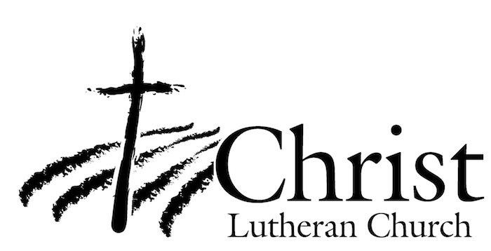
13009 N. Elderberry Ct.
Lodi, CA 95242
www.christlodi.org
209-368-6250
Pastor Timothy Leistekow
WELCOME TO CHRIST EV. LUTHERAN CHURCH!
We preach a message of forgiveness, hope and peace
through the death and resurrection of Jesus Christ.
Families and individuals of all ages will find opportunities
both to grow and to serve.
Our mission statement:
Look what Christ is doing!
He binds us together in fellowship
He gathers us in for worship
He builds us up for service
He sends us out with the gospel

“Now you are the body of Christ,
and each one of you is a part of it.”
(1 Corinthians 12:27)

